www.brightonmitre.co.uk
1894 - 2017
PRESIDENT - FRANK BLAKE
22nd Easter weekend of hilly events
Promoted for and on behalf of Cycling Time Trials under their rules and regulations
22nd Hilly 10 miles time trial
The Alan Packett Memorial Event on course G10/44 Easter Saturday 15th April 2017
Event Secretary: Robin Johnson | 7 Gorselands, Billingshurst, West Sussex RH14 9TT  Email: mr_rjohnson@outlook.com  Tel: 01403 783368 (or 07733 132043 on day of event)

HQ  Kirdford Village Hall  On the north side of the road through the village of Kirdford and 5 miles north-east of Petworth, West Sussex  Postcode RH14 0LY | 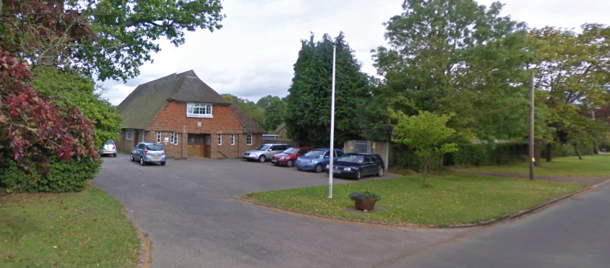
Parking is limited in front of, and to the side of, the hall. Then use one side of the road.

Numbers at HQ only. Return for a drink; food is available.

HQ to start: 0.3 miles Finish to HQ: 2.7 miles

Route to start: Right out of the car park.

Course Records
 | Mens: | 21:40 | Pete Tadros | 2011
 | Ladies: | 26:11 | Liz Milne | 2001
 | Vets | 21:40 | Pete Tadros | 2011
 | Trike | 27:14 | Mike Marchant | 2000
 | Para | 32:11 | Liz Saul | 2015

OFFICIAL TIME KEEPERS
 | Start: | Mick Irons | Worthing Excelsior CC
 | Finish: | Jane Lade | Eastbourne Rovers CC

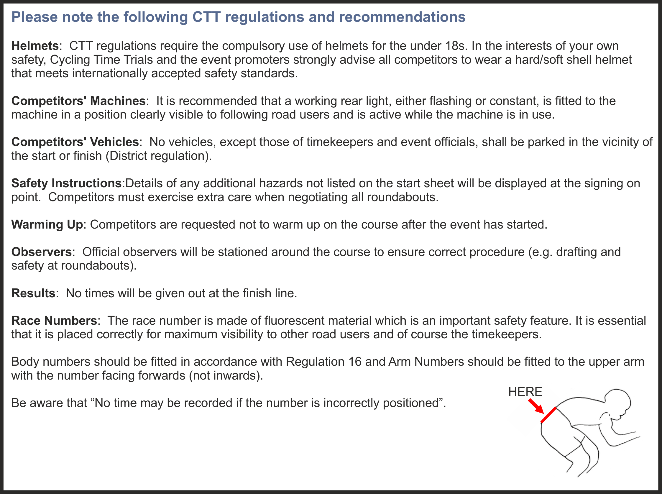

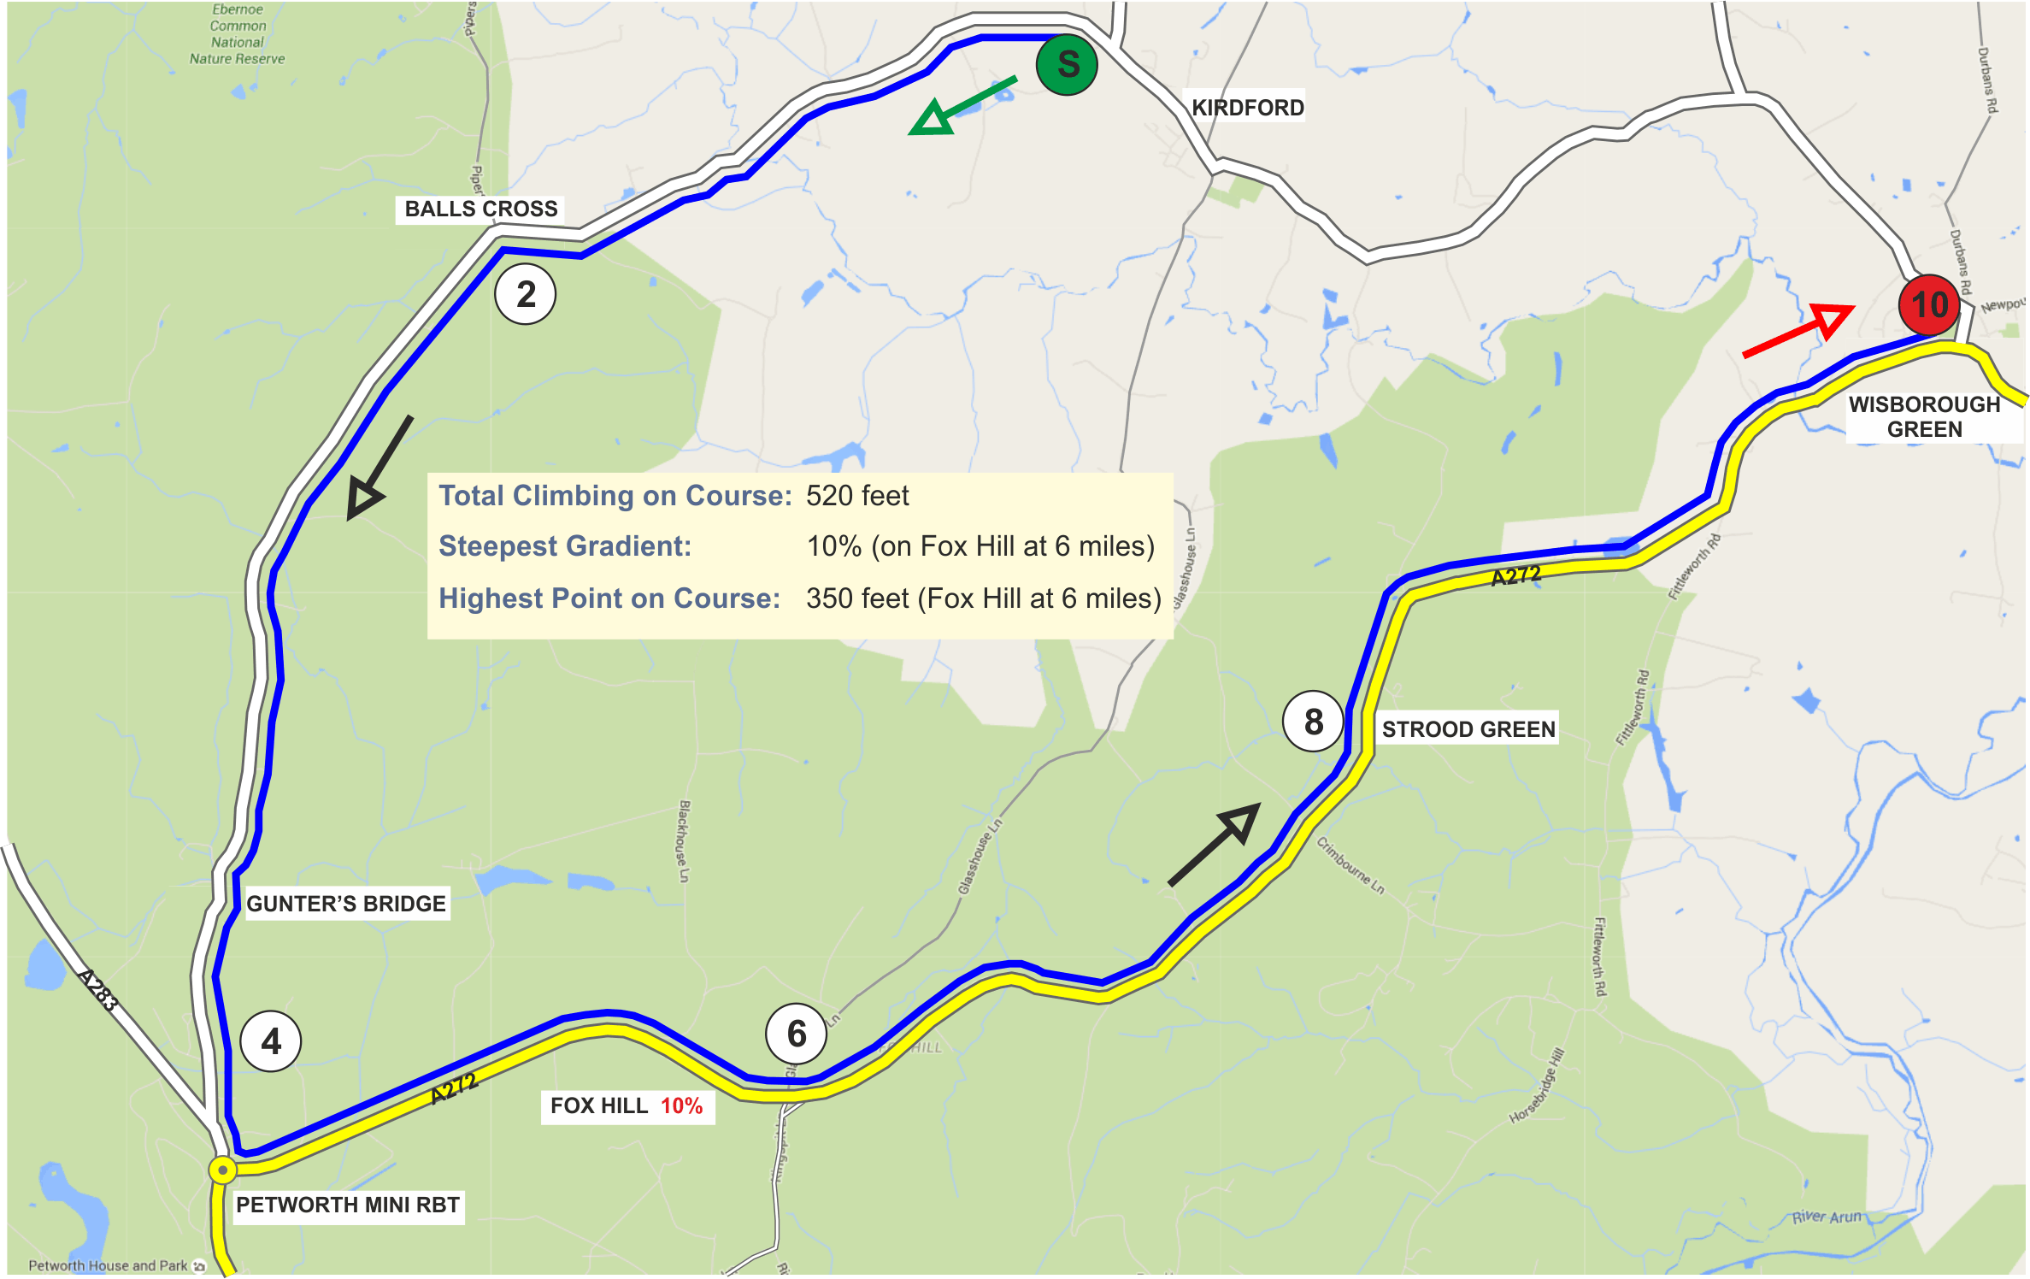
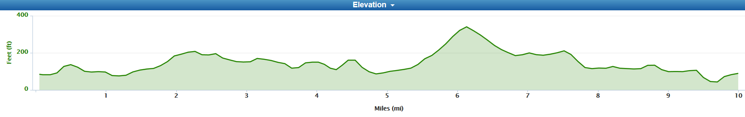
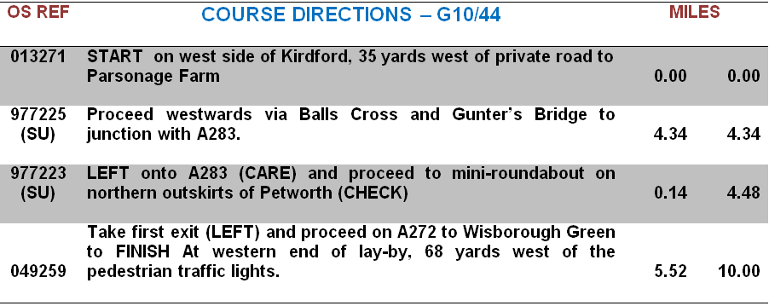

Prizes

Category | Pos | Prize | Category | Pos | Prize
Fastest Overall | 1st | £10 + Champagne + E/Egg (value £26) | Veteran aged 40-44 |  | Wine + Easter Egg (value £6)
 | 2nd | £6 + Wine + Easter Egg (value £6) | Veteran aged 45-49 |  | Wine + Easter Egg (value £6)
 | 2nd | £4 + Wine + Easter Egg (value £6) | Veteran aged 50-54 |  | Wine + Easter Egg (value £6)
 | 4th | Wine + Easter Egg (value £6) | Veteran aged 55-59 |  | Wine + Easter Egg (value £6)
 |  |  | Veteran aged 60-64 |  | Wine + Easter Egg (value £6)
Fastest Lady | 1st | £10 + Wine + Easter Egg (value £6) | Veteran aged 65-69 |  | Wine + Easter Egg (value £6)
 | 2nd | £6 + Wine + Easter Egg (value £6) | Veteran aged 70-74 |  | Wine + Easter Egg (value £6)
 |  |  | Veteran aged 75-79 |  | Wine + Easter Egg (value £6)
Fastest Juvenile |  | Soft drink + Easter Egg (value £4) + | Fastest Team of 3 | 1st | £7 + Wine + Easter Egg (value £6) each
 |  | Brighton Mitre C.C. medal. |  | 2nd | Wine + Easter Egg (value £6) each
ROAD BIKES: 1st - £10 + Wine + Easter Egg (value £6) 2nd - £6 + Wine + Easter Egg (value £6)
PRIZE PRESENTATIONS: | Will be held as soon as possible after the event  Please stay to receive your prizes and/or applaud the recipients
LOTTERY PRIZES: | 2 Bottles of Wine, and 2 Easter Eggs (names drawn from the hat)  To be a possible winner, be present and be a finisher

 | PAST WINNERS - "10"
 | 1996 | Mike Marchant | 23:57
 | 1997 | Tim Stevens | 22:19
 | 1998 | Timothy Bayley | 22:53
 | 1999 | Peter Main | 23:41
 | 2000 | James Millard | 23:56
 | 2001 | Graeme Stirzaker | 23:20
 | 2002 | James Dear | 23:31
 | 2003 | Mark Holtom | 23:18
 | 2004 | Ray Hughes | 23:25
 | 2005 | Ben Instone | 22:15
 | 2006 | Mike Coyle | 22:24
 | 2007 | Pete Tadros | 22:08
 | 2008 | Chris Birch | 23:10
 | 2009 | Pete Tadros | 22:19
 | 2010 | Pete Tadros | 22:17
 | 2011 | Pete Tadros | 21:40 | - COURSE RECORD
 | 2012 | Pete Tadros | 21:46
 | 2013 | Pete Tadros | 22:21
 | 2014 | Pete Tadros | 22:08
 | 2015 | Pete Tadros | 22:14
2016 Pete Tadros (9 wins) 23:18

 | Rider  No | Start  Time | Name | Club | Cat/  Age
 | 8 | 15:08 | Robin Johnson | Brighton Mitre CC | V67
 | 9 | 15:09 | Liz Saul | Para-T | WS
 | 10 | 15:10 | Charl Jean Jordaan | In-Gear Quickvit Trainsharp RT | S
 | 11 | 15:11 | Stephen Morgan | Tooting BC | V47
 | 12 | 15:12 | Alan Robinson | Central Sussex CC | V74
 | 13 | 15:13 | Richard Bayfield | London Phoenix CC | V46 | 00:26:27
 | 14 | 15:14 | Alistair Canning | VC de Londres | JUV
 | 15 | 15:15 | Paul Thatcher | Brighton Mitre CC | V51 | 00:26:50
 | 16 | 15:16 | Sarah Matthews | ...a3crg | WV54 | 00:29:14
 | 17 | 15:17 | James Horan | South Downs Bikes | V45 | 00:26:23
 | 18 | 15:18 | Wendy Frost | Redmon CC | WV44 | 00:28:24
 | 19 | 15:19 | Michael Leonard | South Downs Bikes | V51 | 00:26:50
 | 20 | 15:20 | Jack Donaldson | Neon Velo | S
 | 21 | 15:21 | Stuart Bettis | South Downs Bikes | S
 | 22 | 15:22 | Michelle Arthurs-Brennan | Redhill CC | WS
 | 23 | 15:23 | David Eccles | Redmon CC | V67 | 00:28:32
 | 24 | 15:24 | Joe Kingsman | Hastings & St. Leonards CC | J
 | 25 | 15:25 | Mike O'Gorman | Worthing Excelsior CC | V63 | 00:27:59
 | 26 | 15:26 | Jon Frost | Redmon CC | V48 | 00:26:36
 | 27 | 15:27 | Tim Holmes | VTTA (Surrey & Sussex) | V52 | 00:26:54
 | 28 | 15:28 | Justin Steele | Sussex Nomads CC | V55 | 00:27:09
 | 29 | 15:29 | Jay Chisnall | VTTA (Surrey & Sussex) | V54 | 00:27:04
 | 30 | 15:30 | Gavin Starling | Brighton Mitre CC | V46 | 00:26:27
 | 31 | 15:31 | Jon Fry | Horsham Cycling | V44 | 00:26:18
 | 32 | 15:32 | Claire Leonard | South Downs Bikes | WV43 | 00:28:19
 | 33 | 15:33 | Gina McGeever | Lewes Wanderers CC | WV43 | 00:28:19
 | 34 | 15:34 | Colin Crocker | Sotonia CC | V64 | 00:28:06
 | 35 | 15:35 | Dave Warne | Old Portlians CC | V59 | 00:27:32
 | 36 | 15:36 | Wayne Van Ry | Bigfoot - SCU | V43 | 00:26:13
 | 37 | 15:37 | Barry Robinson | ...a3crg | V40 | 00:25:59
 | 38 | 15:38 | Selena Bartley | Sussex Nomads CC | WV42 | 00:28:13
 | 39 | 15:39 | Barnaby Gray | ...a3crg | V45 | 00:26:23
 | 40 | 15:40 | Marc Clothier | South Downs Bikes | S
 | 41 | 15:41 | Emma Craddock | South Downs Bikes | WS
 | 42 | 15:42 | Mike Boyce | ...a3crg | V59 | 00:27:32
 | 43 | 15:43 | Ashley Baker | Brighton Mitre CC | V46 | 00:26:27
 | 44 | 15:44 | Richard Hoskin | Redmon CC | V68 | 00:28:42
 | 45 | 15:45 | David Shepherd | GS Stella | V54 | 00:27:04
 | 46 | 15:46 | Rachel Clay | ...a3crg | WS
 | 47 | 15:47 | Ross Stringer | Sussex Revolution VC | S
 | 48 | 15:48 | Luke De Quay | East Grinstead CC | S
 | 49 | 15:49 | Paul Barnard | South Downs Bikes | S
 | 50 | 15:50 | Steven Kane | Team ASL360 | S
 | 51 | 15:51 | Matthew Andrews | Horsham Cycling | S
 | 52 | 15:52 | Ben Fielden | GS Stella | V73 | 00:29:39
 | 53 | 15:53 | Thomas Goodyer | Portsmouth North End CC | S
 | 54 | 15:54 | Bruce Samuel | South Downs Bikes | V48 | 00:26:36
 | 55 | 15:55 | Philip Murrell | Finsbury Park CC | V45 | 00:26:23
 | 56 | 15:56 | Geoff Smith | Eastbourne Rovers CC | V64 | 00:28:06
 | 57 | 15:57 | Mark Ayling | CC Abergavenny | V40 | 00:25:59
 | 58 | 15:58 | Katerina Avramides | Brighton Mitre CC | WS
 | 59 | 15:59 | Mark Perry | All Terrain Cycles | S
 | 60 | 16:00 | Peter Tadros | In-Gear Quickvit Trainsharp RT | V44 | 00:26:18

www.brightonmitre.co.uk
1894 - 2017
PRESIDENT - FRANK BLAKE
21st Easter weekend of hilly events
Promoted for and on behalf of Cycling Time Trials under their rules and regulations
26th Hilly 25 miles time trial
The Bill Sladen Memorial Event on course GS/999 Easter Monday 17th April 2017
Event Secretary: Robin Johnson | 7 Gorselands, Billingshurst, West Sussex RH14 9TT  Email: mr_rjohnson@outlook.com  Tel: 01403 783368 (or 07733 132043 on day of event)

HQ  Brighton & Hove Golf Club  http://www.brightongolf.co.uk/  Devils Dyke Road  Brighton  East Sussex BN1 8YJ  Open from 06:00 | 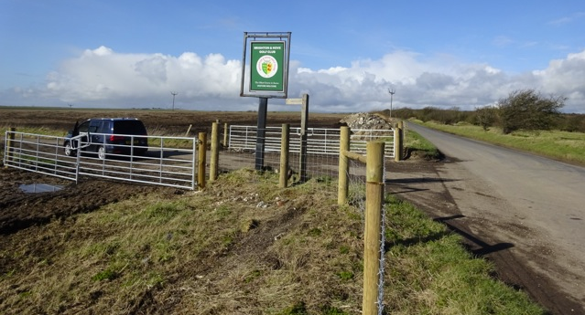
Some parking is available. Park also available in Devils Dyke Road.

Thank you in advance for not wearing cycling shoes or cleats in the club.

Numbers at HQ only. After the event please return your race number to the event HQ in exchange for a cup of tea or coffee.

HQ to start: 1.3 miles Finish to HQ: 1.5 miles

Route to start: Right out of the car park and then right onto Devils Dyke Road. Continue to the start area which is at the junction at the end.

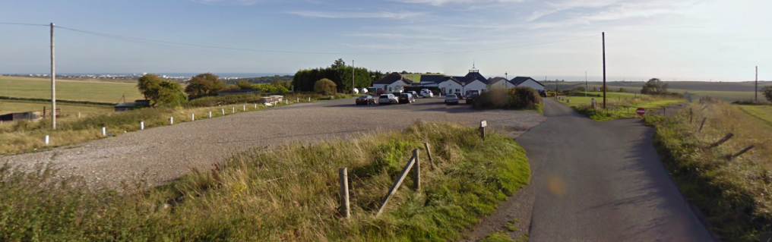

Course Records
 | Mens: | 57:18 | Pete Tadros | 2011
 | Ladies: | 1:11:48 | Lisa Thompson | 2000
 | Vets | 57:18 | Pete Tadros | 2011
 | Trike | 1:10:29 | Mike Marchant | 2000
OFFICIAL TIMEKEEPER
 | Start: | Mike Kilby | Lewes Wanderers CC
 | Finish: | Mike Kilby | Lewes Wanderers CC

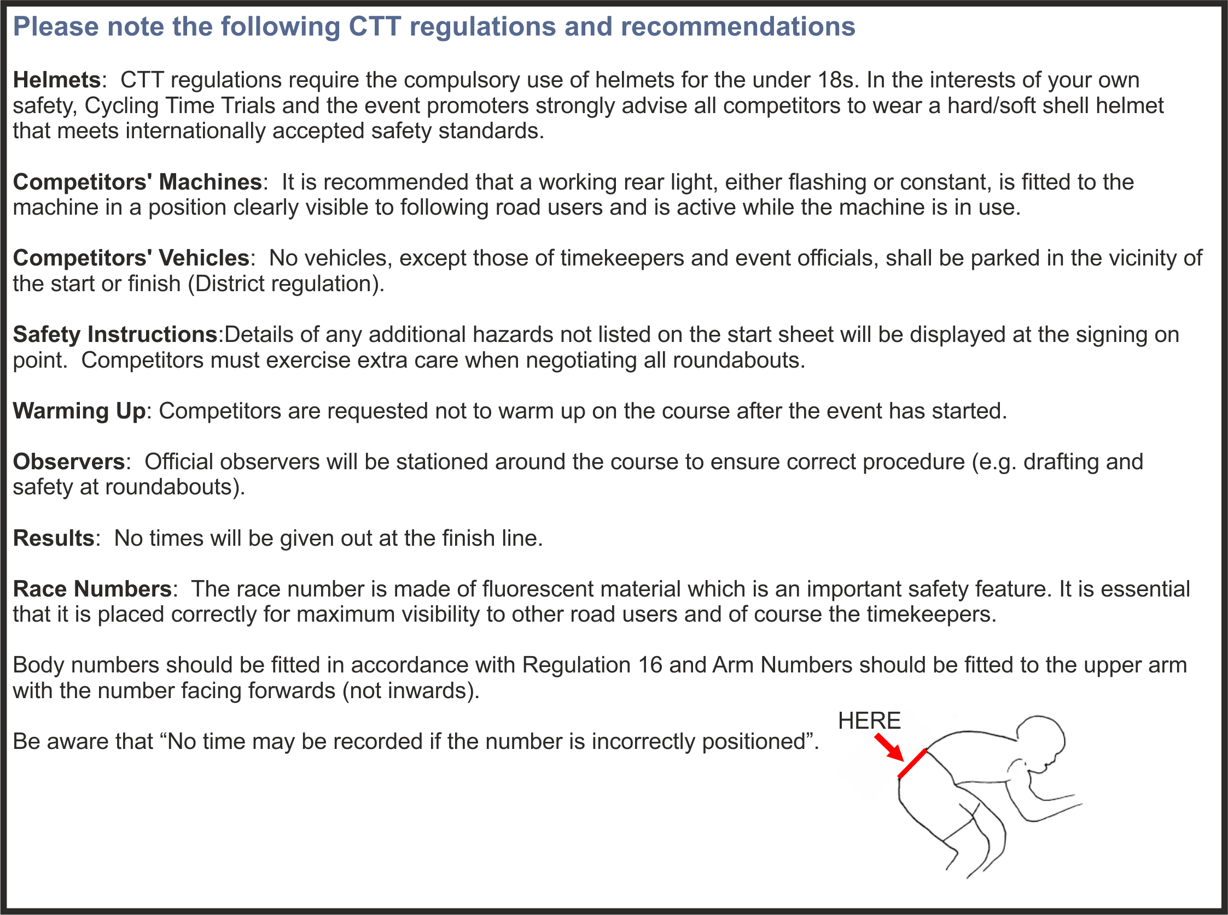

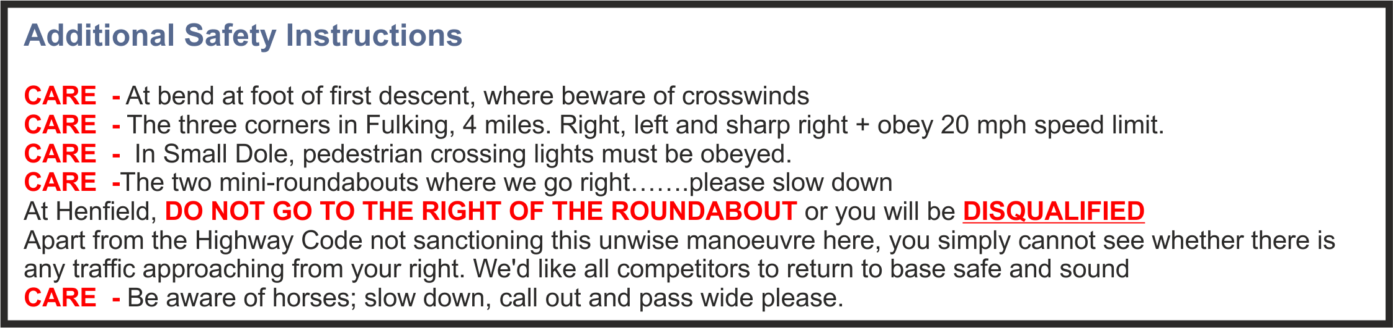

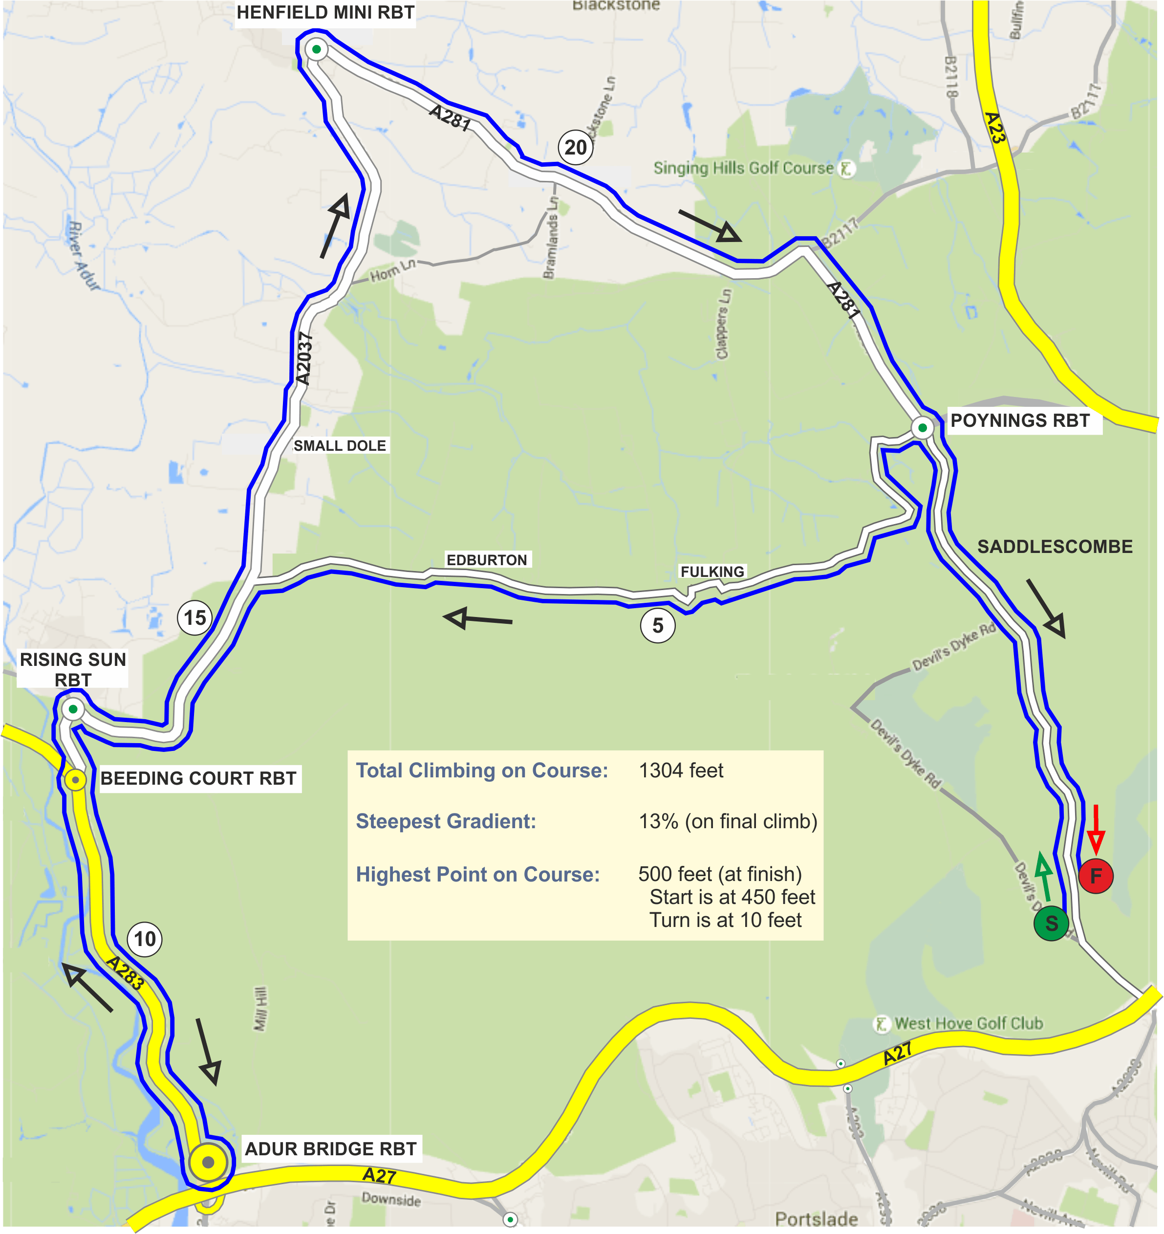
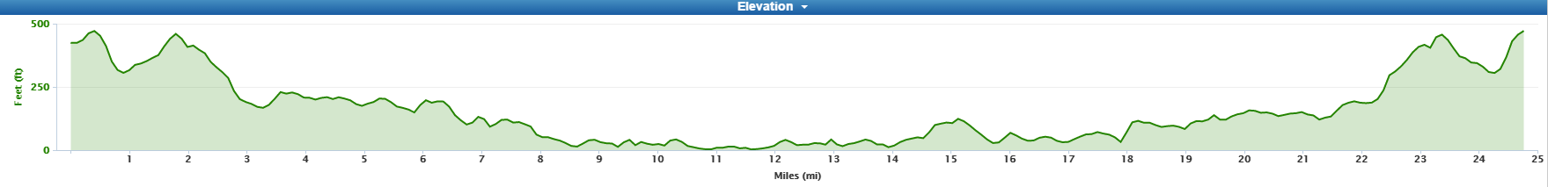
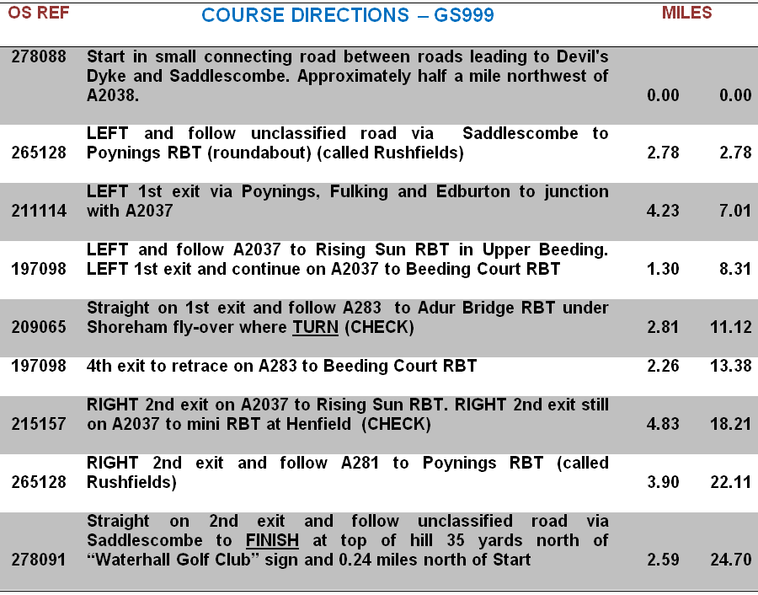

Prizes
Category | Pos | Prize | Category | Pos | Prize
Fastest Overall | 1st | £20 + Champagne + E/Egg (value £26) | Veteran aged 40-44 |  | Wine + Easter Egg (value £6)
 | 2nd | £10 + Wine + Easter Egg (value £6) | Veteran aged 45-49 |  | Wine + Easter Egg (value £6)
 | 3rd | £6 + Wine + Easter Egg (value £6) | Veteran aged 50-54 |  | Wine + Easter Egg (value £6)
 | 4th | £4 + Wine + Easter Egg (value £6) | Veteran aged 55-59 |  | Wine + Easter Egg (value £6)
 | 5th | Wine + Easter Egg (value £6) | Veteran aged 60-64 |  | Wine + Easter Egg (value £6)
 |  |  | Veteran aged 65-69 |  | Wine + Easter Egg (value £6)
Fastest Lady | 1st | Wine + Easter Egg (value £6)
Fastest Juvenile | 1st | Soft drink + Easter Egg (value £4) | Fastest Team of 3 | 1st | £6 + Wine + Easter Egg (value £6) each
 |  |  |  | 2nd | Wine + Easter Egg (value £6 each
ROAD BIKES – 1st: £10 + Wine + Easter Egg (value £6) 2nd: £5 + Wine + Easter Egg (value £6)
PRIZE PRESENTATIONS: | Will be held as soon as possible after the event  Please stay to receive your prizes and/or applaud the recipients
LOTTERY PRIZES: | 2 Bottles of Wine, and 2 Easter Eggs (names drawn from the hat)  To be a possible winner, be present and be a finisher

 | PAST WINNERS - "25"
 | 1992 | Mark Jones | 1:03:18
 | 1993 | Mark Jones | 1:03:21
 | 1994 | Mike Marchant | 1:03:19
 | 1995 | Mark Jones (3 wins) | 1:02:40
 | 1996 | Tim Stevens | 0:57:52
 | 1997 | Tim Stevens | 1:01:16
 | 1998 | Tim Stevens (3 wins) | 1:01:17
 | 1999 | Peter Main | 1:03:21
 | 2000 | Steve Dennis | 0:59:55
 | 2001 | Graeme Stirzaker | 1:01:46
 | 2002 | Pete Tadros | 0:58:43
 | 2003 | Paul Pickup | 1:00:17
 | 2004 | Pete Tadros | 0:59:48
 | 2005 | Pete Tadros | 0:59:41
 | 2006 | Mike Coyle | 0:59:44
 | 2007 | Pete Tadros | 0:57:45
 | 2008 | Mike Coyle (2 wins) | 1:02:15
 | 2009 | Pete Tadros | 0:58:01
 | 2010 | Pete Tadros | 0:59:07
 | 2011 | Pete Tadros | 0:57:18 | - COURSE RECORD
 | 2012 | Pete Tadros | 0:59:07
 | 2013 | Pete Tadros | 0:59:19
 | 2014 | Pete Tadros | 0:57:30
 | 2015 | Pete Tadros (11 wins) | 0:58:01
2016 Not held, Storm Katie.

 | Rider  No | Start  Time | Name | Club | Cat/  Age | VTTA  Std
 | 5 | 07:35 | Robin Johnson | Brighton Mitre CC | V66 | 01:12:20
 | 6 | 07:36 | Thomas Andrews | Albarosa CC | S
 | 7 | 07:37 | Peter Rowe | Southborough & District Wh | V50 | 01:08:02
 | 8 | 07:38 | Andrew Green | Old Portlians CC | V48 | 01:07:38
 | 9 | 07:39 | John Marinko | Brighton Mitre CC | V49 | 01:07:50
 | 10 | 07:40 | Jack Donaldson | Neon Velo | S
 | 11 | 07:41 | Peter Ruane | In-Gear Quickvit Trainsharp RT | V47 | 01:07:26
 | 12 | 07:42 | Tamar Vanderhaas | Lewes Wanderers CC | WS
 | 13 | 07:43 | Paul Thatcher | Brighton Mitre CC | V51 | 01:08:14
 | 14 | 07:44 | Adam Barrett | Brighton Mitre CC | S
 | 15 | 07:45 | Wayne Van Ry | Bigfoot - SCU | V43 | 01:06:39
 | 16 | 07:46 | Stephen Morgan | Tooting BC | V47 | 01:07:26
 | 17 | 07:47 | Kevin Plummer | South Downs Bikes | V49 | 01:07:50
 | 18 | 07:48 | Rhiannon Davies | RST Sport/Aero-Coach | WS
 | 19 | 07:49 | George Welfare | Eastbourne Rovers CC | S
 | 20 | 07:50 | Steven Kane | Team ASL360 | S
 | 21 | 07:51 | Adrian Blacker | Norwood Paragon CC | V51 | 01:08:14
 | 22 | 07:52 | Nigel Langridge | Crawley Wheelers | V50 | 01:08:02
 | 23 | 07:53 | Say Leddington | Old Portlians CC | V46 | 01:07:15
 | 24 | 07:54 | Stephen Gaston | Lewes Wanderers CC | V50 | 01:08:02
 | 25 | 07:55 | Marc Townsend | Eastbourne Rovers CC | S
 | 26 | 07:56 | Matt Peel | Redhill CC | S
 | 27 | 07:57 | Geoff Smith | Eastbourne Rovers CC | V64 | 01:11:36
 | 28 | 07:58 | Daniel Pink | Bigfoot CC | S
 | 29 | 07:59 | Joe Kingsman | Hastings & St. Leonards CC | J
 | 30 | 08:00 | Mark Perry | All Terrain Cycles | S
 | 31 | 08:01 | Richard Cartland | South Downs Bikes | S
 | 32 | 08:02 | Keith Walker | Wigmore CC | V50 | 01:08:02
 | 33 | 08:03 | Mike Marchant | Southdown Velo | V57 | 01:09:34
 | 34 | 08:04 | Katerina Avramides | Brighton Mitre CC | WS
 | 35 | 08:05 | Rob Pelham | Lewes Wanderers CC | S
 | 36 | 08:06 | David Churchill | Bigfoot CC | V56 | 01:09:19
 | 37 | 08:07 | Don Parker | Brighton Mitre CC | V66 | 01:12:20
 | 38 | 08:08 | Luke De Quay | East Grinstead CC | S
 | 39 | 08:09 | Colin Crocker | Sotonia CC | V64 | 01:11:36
 | 40 | 08:10 | Chris McNamara | Pedal Heaven | V40 | 01:06:00
 | 41 | 08:11 | Gavin Starling | Brighton Mitre CC | V46 | 01:07:15
 | 42 | 08:12 | James Stone | Brighton Excelsior CC | V46 | 01:07:15
 | 43 | 08:13 | Mark Ayling | CC Abergavenny | V40 | 01:06:00
 | 44 | 08:14 | Joe Hyatt | Brighton Mitre CC | S
 | 45 | 08:15 | Charl Jean Jordaan | In-Gear Quickvit Trainsharp RT | S
 | 46 | 08:16 | Stu Nisbett | Crawley Wheelers | V41 | 01:06:13
 | 47 | 08:17 | Stuart Bettis | South Downs Bikes | S
 | 48 | 08:18 | David Eccles | Redmon CC | V67 | 01:12:44
 | 49 | 08:19 | Liz Hulland | Crawley Wheelers | WS
 | 50 | 08:20 | Peter Tadros | In-Gear Quickvit Trainsharp RT | V44 | 01:06:51

