www.brightonmitre.co.uk
1894 - 2019
PRESIDENT – ROBIN JOHNSON
24th Easter weekend of hilly events
Promoted for and on behalf of Cycling Time Trials under its rules and regulations
24th Hilly 10 miles time trial
The Alan Packett Memorial Event on course G10/44 Easter Saturday 20th April 2019
Event Secretary: Robin Johnson | 7 Gorselands, Billingshurst, West Sussex RH14 9TT  Email: mr_rjohnson@outlook.com  Tel: 01403 783368 (or 07733 132043 on day of event)

HQ  Kirdford Village Hall  On the north side of the road through the village of Kirdford and 5 miles north-east of Petworth, West Sussex  Postcode RH14 0LY | 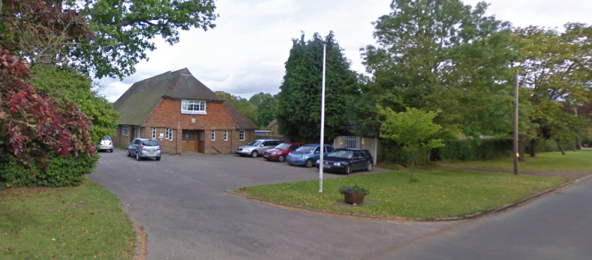
Parking is limited in front of, and to the side of, the hall. Then use one side of the road.

Numbers at HQ only. Return for a drink; food is available.

HQ to start: 0.3 miles Finish to HQ: 2.7 miles

Route to start: Right out of the car park.

Please remember to SIGN ON for your number and to SIGN OUT when you return it.

Course Records
 | Mens: | 21:40 | Pete Tadros | 2011
 | Trike | 27:14 | Mike Marchant | 2000
 | Para | 32:11 | Liz Saul | 2015
 | Juvenile | 25:42 | Theo Tadros | 2017
 | Junior

TIME KEEPERS
 | Start: | Mick Irons | Worthing Excelsior CC
 | Finish: | Jane Lade | Eastbourne Rovers CC
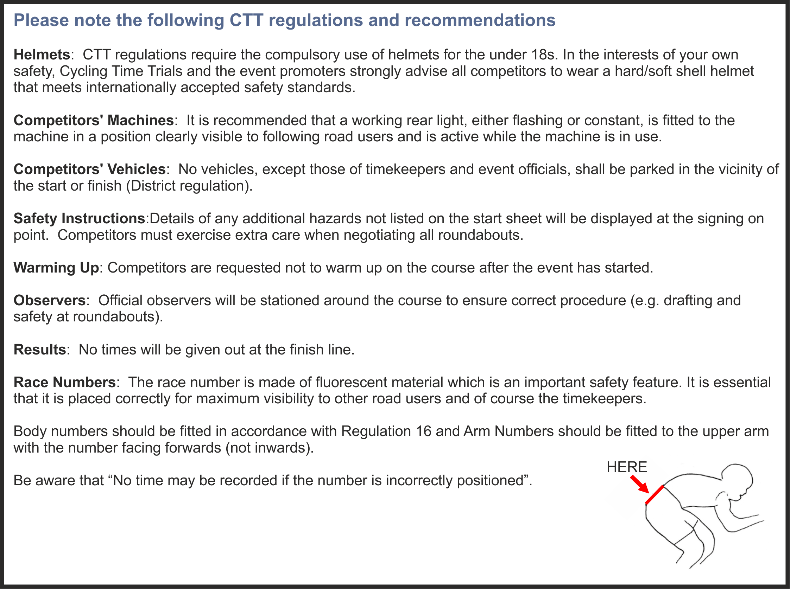

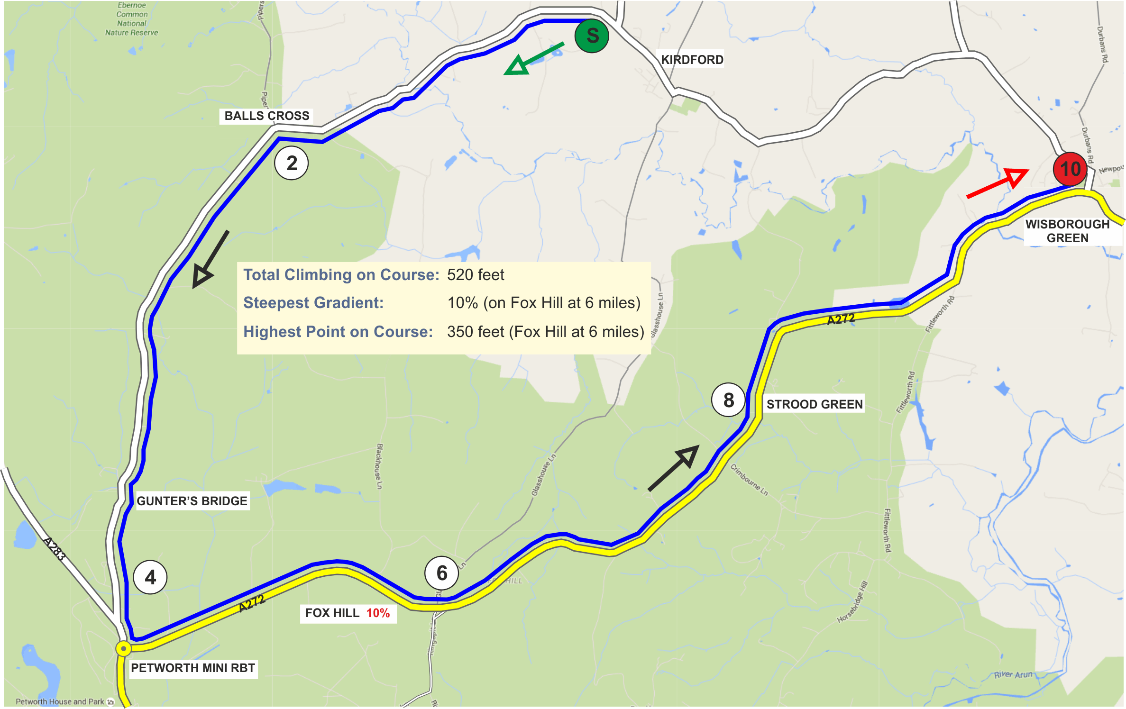
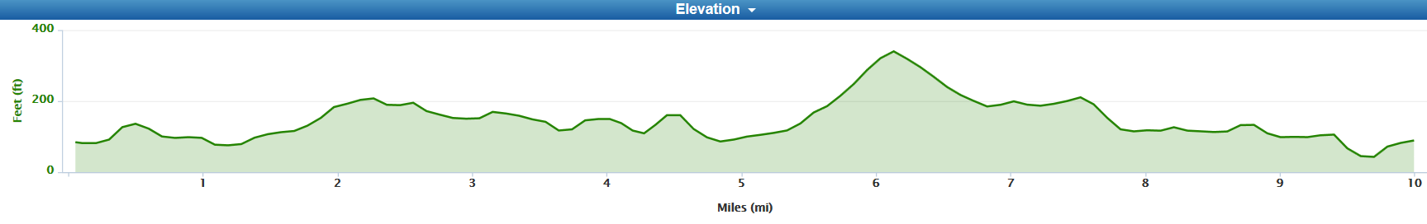
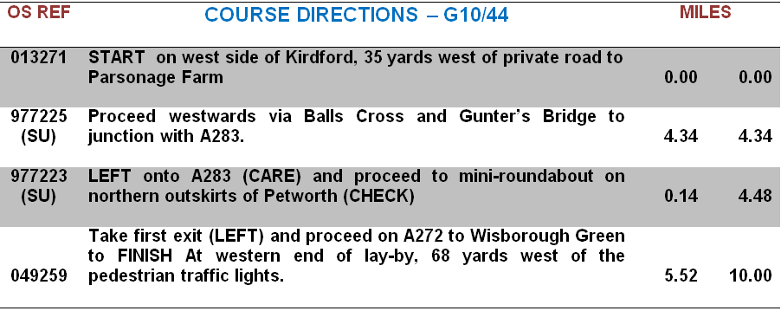

Prizes

Category | Pos | Prize | Category | Pos | Prize
Fastest | 1st | £20 + Champagne + E/Egg (value £26) | Veteran aged 40-44 |  | Wine + Easter Egg (value £6)
 | 2nd | £10 + Wine + Easter Egg (value £6) | Veteran aged 45-49 |  | Wine + Easter Egg (value £6)
 | 2nd | £5 + Wine + Easter Egg (value £6) | Veteran aged 50-54 |  | Wine + Easter Egg (value £6)
 | 4th | Wine + Easter Egg (value £6) | Veteran aged 55-59 |  | Wine + Easter Egg (value £6)
 |  |  | Veteran aged 60-64 |  | Wine + Easter Egg (value £6)
Fastest Lady | 1st | £10 + Wine + Easter Egg (value £6) | Veteran aged 65-69 |  | Wine + Easter Egg (value £6)
 | 2nd | £6 + Wine + Easter Egg (value £6) | Veteran aged 70-74 |  | Wine + Easter Egg (value £6)
 |  |  | Veteran aged 75-79 |  | Wine + Easter Egg (value £6)
 |  |  | Fastest Team of 3 | 1st | £10 + Wine + Easter Egg (value £6) each
 |  |  |  | 2nd | Wine + Easter Egg (value £6) each

ROAD BIKES: 1st - £10 + Champagne + Easter Egg (value £26) 2nd - £6 + Wine + Easter Egg (value £6)
3rd – Wine + Easter Egg (value £6)
PRIZE PRESENTATIONS: | Will be held as soon as possible after the event  Please stay to receive your prizes and/or applaud the recipients
LOTTERY PRIZES: | 3 Bottles of Wine, and 3 Easter Eggs (names drawn from the hat)  To be a possible winner, be present and be a finisher

 | PAST WINNERS - "10"
 | 1996 | Mike Marchant | 23:57
 | 1997 | Tim Stevens | 22:19
 | 1998 | Timothy Bayley | 22:53
 | 1999 | Peter Main | 23:41
 | 2000 | James Millard | 23:56
 | 2001 | Graeme Stirzaker | 23:20
 | 2002 | James Dear | 23:31
 | 2003 | Mark Holtom | 23:18
 | 2004 | Ray Hughes | 23:25
 | 2005 | Ben Instone | 22:15
 | 2006 | Mike Coyle | 22:24
 | 2007 | Pete Tadros | 22:08
 | 2008 | Chris Birch | 23:10
 | 2009 | Pete Tadros | 22:19
 | 2010 | Pete Tadros | 22:17
 | 2011 | Pete Tadros | 21:40 | - COURSE RECORD
 | 2012 | Pete Tadros | 21:46
 | 2013 | Pete Tadros | 22:21
 | 2014 | Pete Tadros | 22:08
 | 2015 | Pete Tadros | 22:14
 | 2016 | Pete Tadros | 23:18
 | 2017 | Pete Tadros (10 wins) | 22:13
 | 2018 | Laurence Manning | 23:02
 | 2019

Bib |  | Start Time | First name | Last name | Club | Gender |  | Category | Age On Day
1 |  | 15:01:00 | Robin | Johnson | Brighton Mitre CC | Male |  | Veteran | 70
2 |  | 15:02:00 | Clive | Jackson | Central Sussex CC | Male |  | Veteran | 66
3 |  | 15:03:00 | Simon | Craig-mcfeely | ...a3crg | Male |  | Veteran | 60
4 |  | 15:04:00 | Gary | Holder | VTTA (Surrey/ Sussex) | Male |  | Veteran | 53
5 |  | 15:05:00 | David | Shepherd | ...a3crg | Male |  | Veteran | 58
6 |  | 15:06:00 | Stephen | Morgan | Tooting BC | Male |  | Veteran | 51
7 |  | 15:07:00 | Tim | Holmes | Brighton Excelsior CC | Male |  | Veteran | 56
8 |  | 15:08:00 | Mark | Ayling | CC Abergavenny / JP Signs & Print | Male |  | Veteran | 44
9 |  | 15:09:00 | Jay | Chisnall | VTTA (Surrey/ Sussex) | Male |  | Veteran | 58
10 |  | 15:10:00 | Sam | Christy | London Dynamo | Male |  | Senior | 26
11 |  | 15:11:00 | Angela | Carpenter | ...a3crg | Female |  | Veteran | 50
12 |  | 15:12:00 | Robin | Harris | Clapham Chasers | Male |  | Veteran | 51
13 |  | 15:13:00 | Gavin | Hughes | Kingston Phoenix RC | Male |  | Veteran | 51
14 |  | 15:14:00 | Alan | Robinson | Central Sussex CC | Male |  | Veteran | 78
15 |  | 15:15:00 | Nik | Allen | Worthing Excelsior CC | Male |  | Veteran | 47
16 |  | 15:16:00 | Andrew R | Green | Bec CC | Male |  | Veteran | 44
17 |  | 15:17:00 | Gary | Bull | Bigfoot CC | Male |  | Veteran | 53
18 |  | 15:18:00 | Mike | Boyce | ...a3crg | Male |  | Veteran | 63
19 |  | 15:19:00 | Angela | Radden-rutt | JAM Cycle Race Team coached by BPC | Female |  | Senior | 39
20 |  | 15:20:00 | Kevin | Tye | VeloRefined.com Aerosmiths | Male |  | Veteran | 57
21 |  | 15:21:00 | James | Griffin | trainSharp | Male |  | Senior | 31
22 |  | 15:22:00 | Jon | Fry | Horsham Cycling | Male |  | Veteran | 48
23 |  | 15:23:00 | Simon | Trehearn | Kingston Phoenix RC | Male |  | Veteran | 45
24 |  | 15:24:00 | Emma | Craddock | South Downs Bikes / Casco Pet | Female |  | Veteran | 43
25 |  | 15:25:00 | Hayley | Simmonds | AeroCoach | Female |  | Senior | 30
26 |  | 15:26:00 | William | Murtagh | Rye & District Wheelers CC | Male |  | Espoir | 21
27 |  | 15:27:00 | Nolan | Heather | Worthing Excelsior CC | Male |  | Veteran | 43
28 |  | 15:28:00 | David | Churchill | Direct Power Cycling Team | Male |  | Veteran | 60
29 |  | 15:29:00 | Nick | Mccormick | Epsom CC | Male |  | Veteran | 55
30 |  | 15:30:00 | Peter | Tadros | trainSharp | Male |  | Veteran | 48
31 |  | 15:31:00 | Stuart | Bettis | South Downs Bikes / Casco Pet | Male |  | Senior | 34
32 |  | 15:32:00 | Steven | Kane | Team ASL | Male |  | Senior | 30
33 |  | 15:33:00 | Richard | Tully | Elite Cycling | Male |  | Veteran | 42
 |  |  |  | ******** | ROAD BIKES’ “10”:
Bib | Start Time |  | First name | Last name | Club | Gender | Category |  | Age On Day
35 | 15:35:00 |  | Peter | Davies | Brighton Mitre CC | Male | Veteran |  | 62
36 | 15:36:00 |  | Ashley | Baker | Bayeux Cycling Team | Male | Veteran |  | 50
37 | 15:37:00 |  | Ben | Fielden | GS Stella | Male | Veteran |  | 77
38 | 15:38:00 |  | Janet | Clapton | Brighton Mitre CC | Female | Veteran |  | 52
39 | 15:39:00 |  | Richard | Hoskin | Redmon CC | Male | Veteran |  | 72
40 | 15:40:00 |  | Matt | Harris | ...a3crg | Male | Senior |  | 36
41 | 15:41:00 |  | Theo | Tadros | trainSharp | Male | Junior |  | 17
42 | 15:42:00 |  | Richard | Cartland | South Downs Bikes / Casco Pet | Male | Veteran |  | 41
43 | 15:43:00 |  | Mike | Marchant | Southdown Velo | Male | Veteran |  | 61
44 | 15:44:00 |  | Chris | Brewer | Redmon CC | Male | Veteran |  | 58
45 | 15:45:00 |  | Andy | Self | North Hampshire RC | Male | Veteran |  | 56
46 | 15:46:00 |  | James | Horan | South Downs Bikes / Casco Pet | Male | Veteran |  | 49
47 | 15:47:00 |  | Robert | Gilmour | Hounslow & District Whs | Male | Veteran |  | 67
48 | 15:48:00 |  | Marc | Clothier | South Downs Bikes / Casco Pet | Male | Veteran |  | 43

www.brightonmitre.co.uk
1894 - 2019
PRESIDENT – ROBIN JOHNSON
24th Easter weekend of hilly events
Promoted for and on behalf of Cycling Time Trials under their rules and regulations
28th Hilly 25 miles time trial
The Bill Sladen Memorial Event on course GS/999 Easter Monday 22nd April 2019
Event Secretary: Robin Johnson, | 7 Gorselands, Billingshurst, West Sussex RH14 9TT  Email: mr_rjohnson@outlook.com  Tel: 01403 783368 (or 07733 132043 on day of event)

HQ

Saddlescombe Farm NATIONAL TRUST property – no parking permitted on the property.
Milking Parlour
Saddlescombe Farm
Saddlescombe Road
Saddlescombe
BN45 7DE

0.9 mile south of Rushfields/Poynings roundabout

NO parking is available. Some parking available in Devils Dyke Road, long lay-by.

Numbers at HQ only. After the event please return your race number to the event HQ in exchange for a drink.

HQ to start: 2.0 miles ALLOW 15 minutes (includes final climb)

Route to start: LEFT out of the car park and continue UPHILL to the start area which is at the junction at the top.

Please remember to SIGN ON for your number and to SIGN OUT when you return it.

Course Records
 | Mens: | 57:18 | Pete Tadros | 2011
 | Ladies: | 1:11:48 | Lisa Thompson | 2000
 | Vets | 57:18 | Pete Tadros | 2011
 | Trike | 1:10:29 | Mike Marchant | 2000

TIMEKEEPER
 |  | Mike Irons | Worthing Excelsior CC

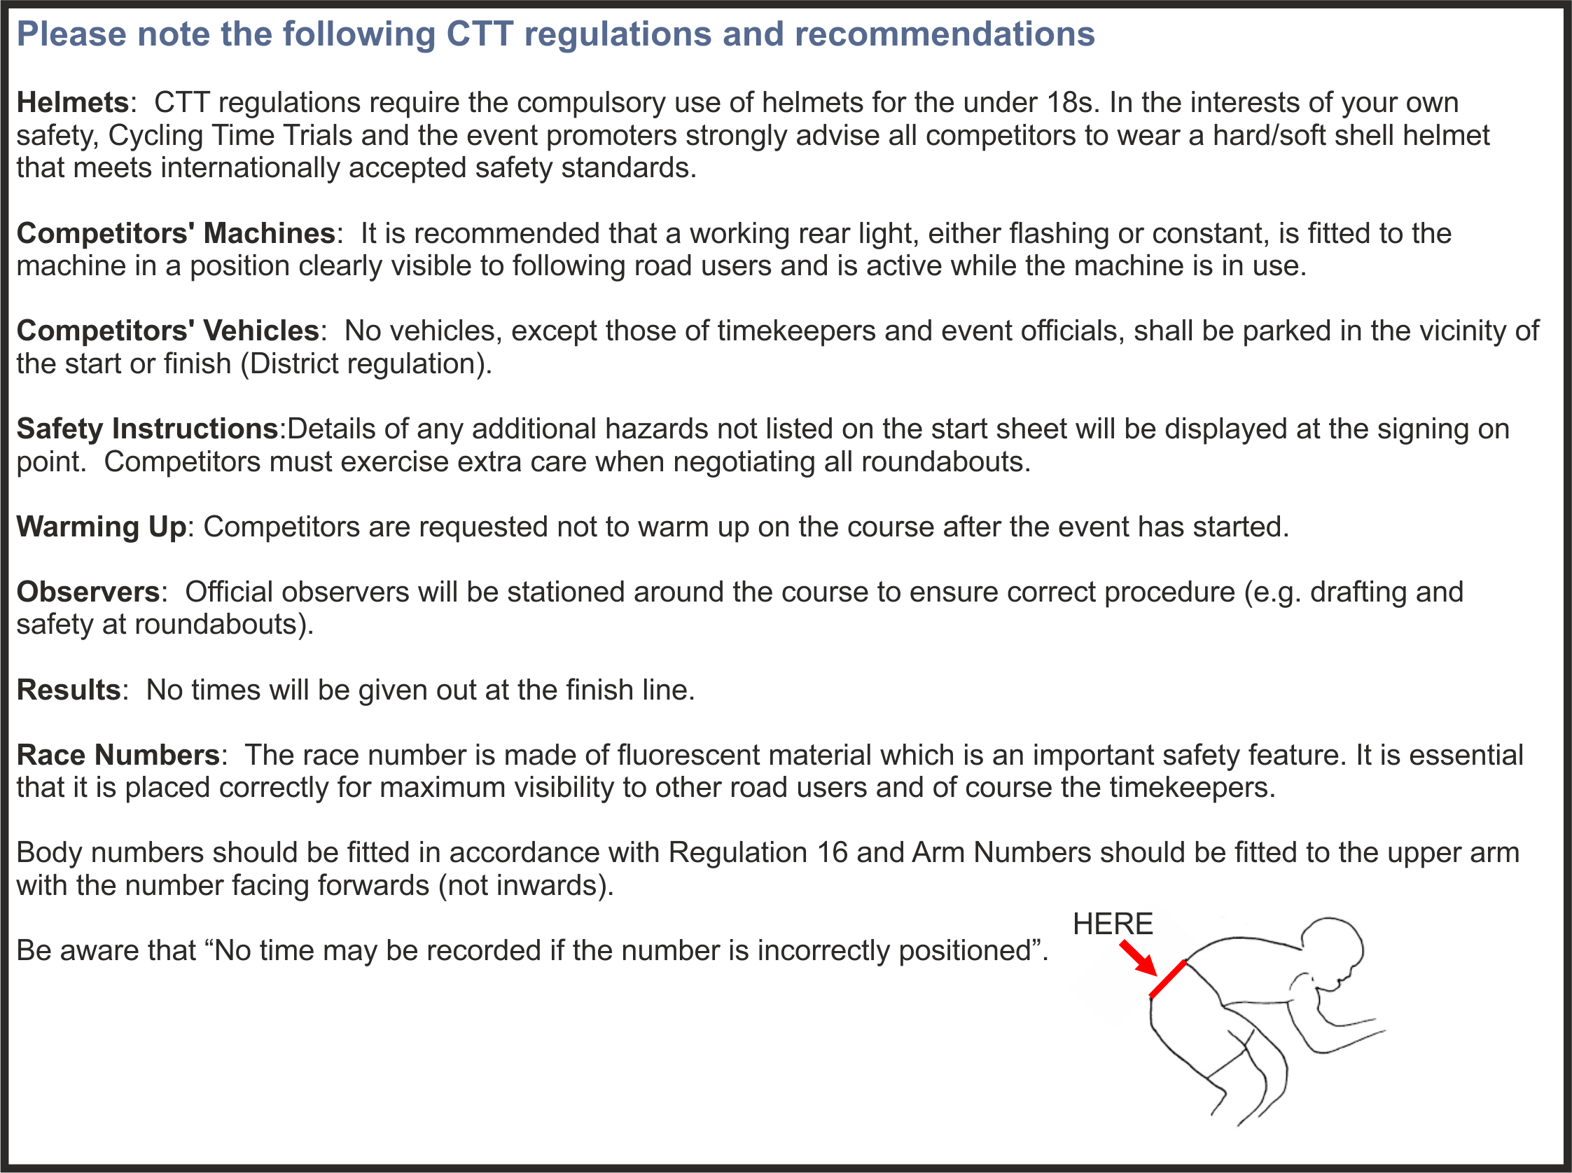

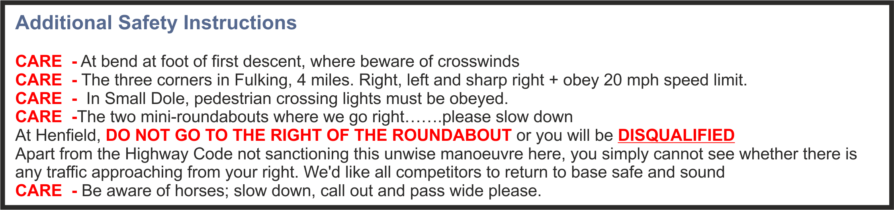

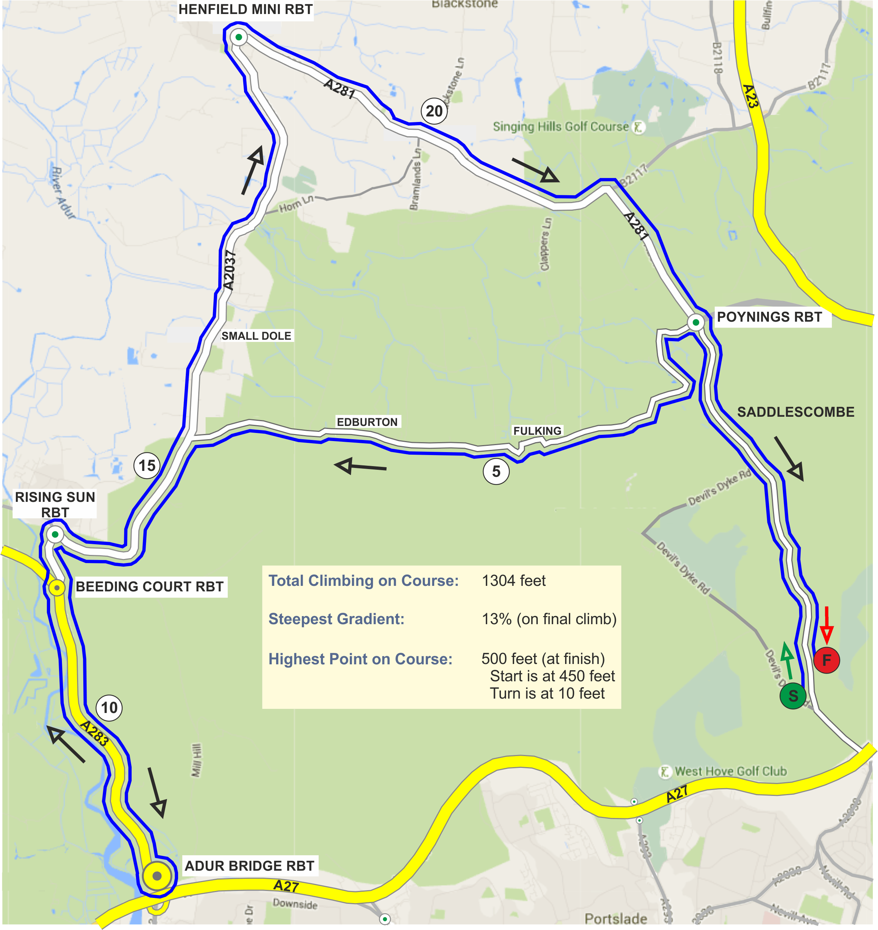
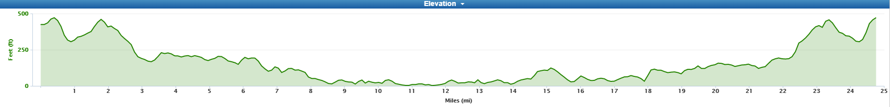
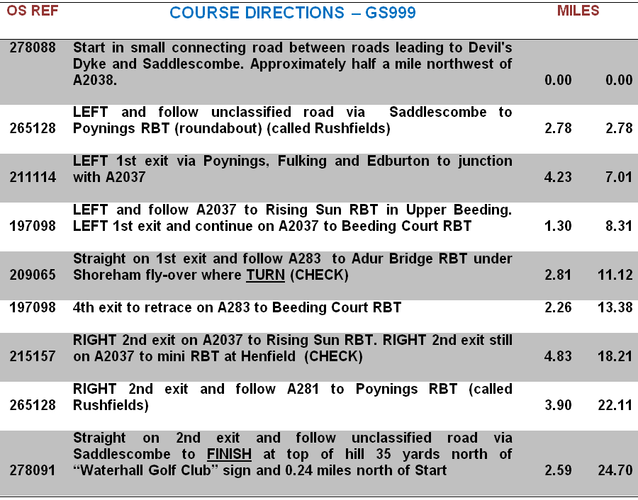
Prizes
Category | Pos | Prize | Category | Pos | Prize
Fastest | 1st | £30 + Champagne + E/Egg (value £26) | Veteran aged 40-44 |  | Wine + Easter Egg (value £6)
 | 2nd | £15 + Wine + Easter Egg (value £6) | Veteran aged 45-49 |  | Wine + Easter Egg (value £6)
 | 3rd | £10 + Wine + Easter Egg (value £6) | Veteran aged 50-54 |  | Wine + Easter Egg (value £6)
 | 4th | £5 + Wine + Easter Egg (value £6) | Veteran aged 55-59 |  | Wine + Easter Egg (value £6)
 | 5th | Wine + Easter Egg (value £6) | Veteran aged 60-64 |  | Wine + Easter Egg (value £6)
 |  |  | Veteran aged 65-69 |  | Wine + Easter Egg (value £6)
Fastest Woman | 1st | £10 + Wine + Easter Egg (value £6) | Veteran aged 70-74 |  | Wine + Easter Egg (value £6)
 | 2nd | Wine + Easter Egg (value £6) | Fastest Team of 3 | 1st | £10 + Wine + Easter Egg (value £6) each
 |  |  |  | 2nd | Wine + Easter Egg (value £6 each

ROAD BIKES – 1st: £15 + Champagne + Easter Egg (value £26) 2nd: £10 + Wine + Easter Egg (value £6)
3rd £5 + Wine + Easter Egg (value £6)
PRIZE PRESENTATIONS: | Will be held as soon as possible after the event  Please stay to receive your prizes and/or applaud the recipients
LOTTERY PRIZES: | 3 Bottles of Wine, and 3 Easter Eggs (names drawn from the hat)  To be a possible winner, be present and be a finisher

 | PAST WINNERS - "25"
 | 1992 | Mark Jones | 1:03:18
 | 1993 | Mark Jones | 1:03:21
 | 1994 | Mike Marchant | 1:03:19
 | 1995 | Mark Jones (3 wins) | 1:02:40
 | 1996 | Tim Stevens | 0:57:52
 | 1997 | Tim Stevens | 1:01:16
 | 1998 | Tim Stevens (3 wins) | 1:01:17
 | 1999 | Peter Main | 1:03:21
 | 2000 | Steve Dennis | 0:59:55
 | 2001 | Graeme Stirzaker | 1:01:46
 | 2002 | Pete Tadros | 0:58:43
 | 2003 | Paul Pickup | 1:00:17
 | 2004 | Pete Tadros | 0:59:48
 | 2005 | Pete Tadros | 0:59:41
 | 2006 | Mike Coyle | 0:59:44
 | 2007 | Pete Tadros | 0:57:45
 | 2008 | Mike Coyle (2 wins) | 1:02:15
 | 2009 | Pete Tadros | 0:58:01
 | 2010 | Pete Tadros | 0:59:07
 | 2011 | Pete Tadros | 0:57:18 | - COURSE RECORD
 | 2012 | Pete Tadros | 0:59:07
 | 2013 | Pete Tadros | 0:59:19
 | 2014 | Pete Tadros | 0:57:30
 | 2015 | Pete Tadros | 0:58:01
 | 2016 | Not held, Storm Katie
 | 2017 | Pete Tadros (12 wins) | 0:59:35
 | 2018 | Mark Smith | 1:02:11
 | 2019

Bib | Start Time | First name | Last name | Club | Gender | Category | Age On Day
1 | 07:31:00 | Robin | Johnson | Brighton Mitre CC | Male | Veteran | 70
2 | 07:32:00 | Tom | Sanderson | Phoenix Cycling Club | Male | Veteran | 45
3 | 07:33:00 | Jamie | Smith | Brighton Mitre CC | Male | Veteran | 46
4 | 07:34:00 | Gemma | Freeman | Brighton Triathlon Club | Female | Senior | 31
5 | 07:35:00 | Simon | Arnold | Oxted Cycle Club | Male | Senior | 26
6 | 07:36:00 | Stu | Nisbett | Crawley Wheelers | Male | Veteran | 45
7 | 07:37:00 | Peter | Owen | Norwood Paragon CC | Male | Veteran | 58
8 | 07:38:00 | Alan | Scott | Clapham Chasers | Male | Senior | 38
9 | 07:39:00 | Katerina | Avramides | Brighton Mitre CC | Female | Senior | 38
10 | 07:40:00 | Steve | Dennis | East Grinstead CC (Merlin Cycle Coaching) | Male | Veteran | 55
11 | 07:41:00 | Andrew R | Green | Bec CC | Male | Veteran | 44
12 | 07:42:00 | Colin | Gray | Norwood Paragon CC | Male | Veteran | 57
13 | 07:43:00 | Lara | Taylor | Velo Club Godalming & Haslemere | Female | Veteran | 46
14 | 07:44:00 | Rory | Maguire | Clapham Chasers | Male | Senior | 37
15 | 07:45:00 | Howard | Bayley | Blazing Saddles | Male | Veteran | 44
16 | 07:46:00 | Nick | Mccormick | Epsom CC | Male | Veteran | 55
17 | 07:47:00 | Ben | Cumpstone | Brighton Mitre CC | Male | Veteran | 49
18 | 07:48:00 | Vince | Freeman | Brighton Triathlon Club | Male | Senior | 39
19 | 07:49:00 | James | Cheeseman | N+1 - Lindfield Coffee Works | Male | Senior | 33
20 | 07:50:00 | Stuart | Bettis | South Downs Bikes / Casco Pet | Male | Senior | 34
21 | 07:51:00 | John | Mcgrath | Worthing Excelsior CC | Male | Veteran | 55
22 | 07:52:00 | Dan | Pullen | N+1 - Lindfield Coffee Works | Male | Veteran | 43
23 | 07:53:00 | Emma | Craddock | South Downs Bikes / Casco Pet | Female | Veteran | 43
24 | 07:54:00 | Donald | Parker | Brighton Mitre CC | Male | Veteran | 70
25 | 07:55:00 | Simon | Mcnamara | South Downs Bikes / Casco Pet | Male | Veteran | 44
26 | 07:56:00 | Richard | Tully | Elite Cycling | Male | Veteran | 42
27 | 07:57:00 | Tony | Reeves | GS Stella | Male | Veteran | 47
28 | 07:58:00 | Stephen | Morgan | Tooting BC | Male | Veteran | 51
29 | 07:59:00 | Neil | Crowther | Blazing Saddles | Male | Veteran | 45
30 | 08:00:00 | Pat | Wright | Paceline RT | Male | Senior | 34
31 | 08:01:00 | Chris | Newberry | Redhill CC | Male | Senior | 31
32 | 08:02:00 | James | Griffin | trainSharp | Male | Senior | 31
33 | 08:03:00 | Nigel | Langridge | Crawley Wheelers | Male | Veteran | 54
34 | 08:04:00 | Simon | Craig-mcfeely | ...a3crg | Male | Veteran | 60
35 | 08:05:00 | Hayley | Simmonds | AeroCoach | Female | Senior | 30
36 | 08:06:00 | Adrian | Blacker | C and N Cycles RT | Male | Veteran | 55
37 | 08:07:00 | Steven | Kane | Team ASL | Male | Senior | 30
38 | 08:08:00 | Keith | Walker | Wigmore CC | Male | Veteran | 54
39 | 08:09:00 | Mike | Boyce | ...a3crg | Male | Veteran | 63
40 | 08:10:00 | Peter | Tadros | trainSharp | Male | Veteran | 48
41 | 08:11:00 | James | Goward | Farnborough & Camberley CC | Male | Veteran | 47
 |  |  | ********** | ROAD BIKES’ “25”:
Bib | Start Time | First name | Last name | Club | Gender | Category | Age On Day
43 | 08:13:00 | Andy | Bone | Brighton Mitre CC | Male | Veteran | 53
44 | 08:14:00 | Ross | Mccracken | URDT | Male | Senior | 27
45 | 08:15:00 | Marc | Clothier | South Downs Bikes / Casco Pet | Male | Veteran | 43
46 | 08:16:00 | Peter | Davies | Brighton Mitre CC | Male | Veteran | 62
47 | 08:17:00 | Glenda | Goscomb | 7Oaks Tri Club | Female | Veteran | 60
48 | 08:18:00 | Jim | Whitelegg | Brighton Phoenix Athletic Club | Male | Veteran | 51
49 | 08:19:00 | Mark | Day | URDT | Male | Senior | 29
50 | 08:20:00 | Theo | Tadros | trainSharp | Male | Junior | 17
51 | 08:21:00 | Richard | Cartland | South Downs Bikes / Casco Pet | Male | Veteran | 41
52 | 08:22:00 | Justin | Webb | Virtual Cycling Club | Male | Veteran | 40
53 | 08:23:00 | Karen | Mcgrath | Worthing Excelsior CC | Female | Veteran | 57
54 | 08:24:00 | Tomas | Navickas | Brighton Mitre CC | Male | Senior | 27
55 | 08:25:00 | Neil | Harrigan | Gravesend CC | Male | Veteran | 45
56 | 08:26:00 | John | Marinko | Brighton Mitre CC | Male | Veteran | 53
57 | 08:27:00 | David | Pena | Blazing Saddles | Male | Senior | 39
58 | 08:28:00 | Mike | Marchant | Southdown Velo | Male | Veteran | 61
59 | 08:29:00 | James | Horan | South Downs Bikes / Casco Pet | Male | Veteran | 49
60 | 08:30:00 | David | Pollard | In-Gear | Male | Veteran | 61

