Brighton Mitre AGM
Wednesday 27th February 2019

Minutes & Record of Decision and Elections

Chairs welcome address.
The current Chair. Elaine Burroughs, welcomed about 40 members to the AGM, thanked everyone for coming and also made a special thanks to all of the committee, volunteers and event organisers for the last 12 months. The club has a really vibrant and active group of people who regularly give up their free time in order to make the club what it is and to support and help its members. A special note, the club IS its members. We can only do as much as we have people willing to put the effort in for your interests… and we thank you all.
We had no apologies for absence from the outgoing committee.
Elaine made a short-lived attempt to be amusing which fell on its face and then swiftly moved on to the committee updates.
Review of 2018 by each section lead;
- Digital past and Social future – Tony Milsom
Tony took us through our digital footprint and shared some google stats of website hits and click throughs indicating that people visited more than one page and did navigate around the website, mostly downloading route files but also the ride schedules and some special events. BMCC have over 1000 page likes which is the most popular of all the local clubs with Crawley Wheelers second with 678. He then finished off by highlighting all of the events that are planned for 2019, including the Majorca training camp later this month, the Brighton Marathon companion event (50Km closed road ‘sportive’) IOW Randonee, Dieppe 24, Hove Park Crit final night social. Summer BBQ and 125th Anniversary ride. Lots to look forward to. As you know social and ride events don’t just happen and we need members to step forward to help by offering time and some coordination efforts. Nothing is difficult, there is plenty of help and advice on hand from the committee, please speak to Tony if you have any ideas for events this year or would like some advice/support setting one up. Trip to Yorkshire for the worlds maybe?

- Membership, Women's Development & Sunday Ride Captain – Alison Lewis
Membership is growing steadily on last year with 258 members, representing a 6% increase. (11 life members and 4 second claim)
17% of our membership are women which is slightly above national average and we have an active women’s social and event contingent. Time trials and hill climbs last year were very well attended by the Mitre women and Cyclocross, Circuit and Track racing also saw increased numbers of women Mitre entries. Last week’s Preston park Circuit racing saw a record 10 Mitre women line up on the start line for the 3rd/4th race. The Mitre women also have a monthly social evening in someone’s house or a local pub for a chance to get together and chat.
The Sunday led rides have now been augmented with non led Sunday rides on the 2nd & 4th Sundays and the 1st & 3rd led Sundays rides continue to be a great entry point for new members into the club as they build confidence and fitness. On the 38 led rides in 2018 we had 470 riders, 15 regular ride leaders with an average attendance on the Come & Try it rides of 6.6 and the Steady Social of 18.6 so good numbers and indicating that these rides are providing a valuable and needed opportunity for members and non members alike. (85% attendees being members and 68% men, 32% women.)
Congratulations to Alison and all Sunday ride leaders for continuing to support, encourage and promote the club to new and prospective members and make everyone feel welcome.
- Road Racing – Mike Coyle
Mike gave a race round up, highlighting the recent successes of Lawrence and Finn and also the new young riders coming up into the senior race squad as they had just completed their first 2/3 race at Preston Park on restricted gearing and put in stellar performances.
- TT – Robin Johnson
Robin spoke about the last season of Time Trials and encouraged more members to come along and give them a go, including the club Hill climbs which are local events and often see more visiting club entries than Mitres. The results are now live on the website and once again, the Mitre women continue to top the leader boards with club and regional awards. Katerina Avramides setting a new women’s course record on the Hard Riders 25. At the awards dinner this year a total of 19 medals were awarded to members for achieving club Time Trail standards.
http://www.brightonmitre.co.uk/racing/time-trial-results-2018/

- CycloCross – Dan Fagg
2018 saw 15 Mitre members regularly riding in the SE and London CycloCross League events which is a marked increase on last year, helped by the fact that 3 of the events were local to Brighton in Stanmer and East Brighton Park.
In the LCCA Alison Lewis won 2nd place Vet 50 Women, Clare Johnson won 3rd in the Vet 50 Women, Isobel Beattie, 2nd in Vet 40 women, Phil Tarry 14th on the Vet 50 Men, Martin O’Brien 27th on the Vet 50 men and Giles Ruffer 10th in the Senior Men. Dan also alluded to more off road events and training next year with Alison qualifying as a BC CycloCross coach and the possibility of Mitre being able to put on our own event.
- Treasurer – Simon Dowling
The club has a healthy bank balance and currently sits at £12,789 after taking into account all current commitments. Overall profit for the year is £3.1k and turnover almost £39k. The committee welcomes ideas from members as to how the club funds might be invested in order to support local cycling, club members or community events.
- Preston Park Track – Wendy Harman
Although Wendy isn’t the club track officer she kindly agreed to talk to us about the Sussex Cycle Racing League events at Preston Park. Events held at Preston Park using both track and road bikes. The 2018 Track Race series saw 6 men and 3 Women Mitre members fight it out on the Friday and Wednesday evening meets last summer. The Friday track league being won my Mitre Ed Raynard and Martin Edmonds in third and the Women’s Wednesday Trophy won by Janet Clapton who recently moved over to the Mitre from Sussex Nomads.
The Sunday and Friday Circuit racing was incredibly popular last year with 15 Mitre men and 7 Mitre women regularly racing on road bikes around the track with Alison Lewis securing 3rd place overall in the women’s circuit series trophy.
Anyone wishing to race track bikes at Preston Park need to attend an accreditation session which are being held on Friday 5th, 12 April and the 3rd May in the evenings. Anyone can ride the circuit race series with a race legal road bike.
The Circuit series is underway with 2 events so far. The first 6 are on Sunday mornings (Feb 24th, Mar 3rd, 10th, 17th, 24th & 31st) and then the last 6 on a Friday evening (May 17th & 31st, Jun 14th & 28th, Jul 12th & 26th) All events include Juniors, Women’s 3/4 Cat , 4th Cat and 2/3 Cat. The first women’s event saw 17 riders with 10 Mitres and a very wet 2nd race had 14 on the line with 7 Mitres. Well done to Giles Ruffer for winning the men’s 4th with a solo breakaway. Enter via British Cycling, more information www.scrl.co.uk

Election of committee (Every post is up for re-election. Each nominated needs a proposer and a seconder and then goes to the vote. There were no competing applications for positions so all of those who were nominated were duly elected.
Chair Elaine Burroughs
Secretary Elaine Burroughs
Treasurer Neil Morris *new
Road Mike Coyle
TT Robin Johnson
CX Dan Fagg
Track Janet Clapton *new
Communications & Digital Media Paul Griffin *new
Social Secretary Tony Milsom
Kit Paul Hulse
Membership Secretary Alison Lewis
Women’s Development Alison Lewis

A special mention and huge thanks and recognition to our 3 outgoing committee members for their hard work and dedication. Simon Dowling (Treasurer) , Martin Thomas (Media & Comms) and Alan Newman (Track)

Exceptional items for membership vote;
- Summer club kit
A number of members had expressed a desire to have a summer kit option that was cooler to wear than the dark blue. Paul requested options for kit design from Kalas which retained our club branding/logo and layout but replacing the Navy Blue for white. This strip is for social riding only; it is not registered colours for racing.
The vote was put as to;
Do we have a white summer kit option?
If Yes, which option?
As this is the 125th Anniversary year for the club it was proposed that the white summer kit be a one-time limited edition which would include a 125th Anniversary and ‘Estd 1894’. This was a very popular idea and the vote was carried that we would produce a summer kit.
We will produce a limited edition 125th Anniversary summer jersey in white as below. Paul Hulse will request the mock up to include the additions of the date etc and circulate with kit ordering details.
Please note this is for summer short-sleeved jerseys ONLY. Please do not ask Paul for other options.
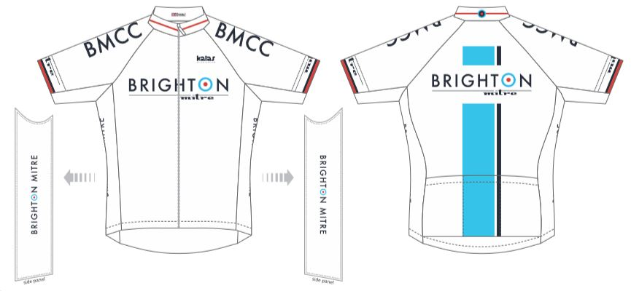
- Mudguards
The club has held an informal rule for several years now that between the dates of the clocks changing to GMT (Ie not BST) that requests members use, at least, a long fitting rear mudguard for all CLUB rides. The club has also provided free ‘flaps’ for the bottom of guards which members have been able to get from the café as winter approaches.
It was put to the vote that we make that club rule formal and document it in the constitution. The vote was carried in favour of making the rule formal and updating our code of conduct section in the constitution as an expectation for members on club rides.
We do not want to become a draconian club that is not inclusive and welcoming. We are a respectful and considerate group of riders and as such the club expects that riders afford their fellow club members due care and consideration when riding behind them in winter conditions. We will add a statement to our constitution, which uses the wording “the club expects riders to fit mudguards out of consideration to their fellow club members during the winter months”
We will not turn anyone away from a ride if they turn up without guards but they will be asked to remain at the back of the group and receive plenty of helpful advice as to how they can fit their guards for the next ride.
- Facebook
It has been noted that there are over 550 Facebook group members who are not members of the club and are able to view all of the posts made by club members.
A number of members have requested that we consider closing our Facebook group to members only on security grounds. As we do not know and cannot verify the identities of our Facebook group members when it is an open group than we risk sharing personal information unknowingly.
Vote; Should we make our Facebook group page private and accessible for members only?
Vote was unanimously carried for a ‘Yes’
Tony will send out the notices and begin the access management process to remove non members from the Facebook group. Our Mitre Facebook page will remain accessible to all and club activities and social events will still be visible her but the personal social nature of the group will be protected for members only.
Currently our club Strava account is private and only open to club members and this is managed by Tony manually. He has confirmed that he is able to also manage the Facebook group membership in the same way.
AOB
One item of AOB was raised by Ray which was to ask if there would be a possibility to start up a regular social meet for club members. To enable those who ride and those who don’t, to catch up with each other, talk about races, equipment kit or just life and families. It was proposed that we should hold one of the post ride beers after a Thursday night summer ride in the same pub each month so as to generate a regular momentum of post ride beers and also anyone who cant make the ride to still come along and catch up with members.
Once we restart the Thursday night rides we will post the name of the pub and which Thursday each month we will be there. (and let Ray know as he doesn’t use Facebook and he is buying the beers )

Without any further comments or business, the meeting was closed at 2130.

